

American International University- Bangladesh

CSC 3222: Web Technologies

CO1.1 and CO2.1 Evaluation

Project Report

Fall 21-22

Project Title:  Social Network System for Job Placement

Section: J

|  |  |
| --- | --- |
| Student Name | Student Id |
| Shahabuddin, Fouzul Kabir | 17-35017-2 |
| Ami, Nooren Zabran | 18-37915-2 |
| Rahman Mohaimenur | 19-40338-1 |
| Mahmudul Hasan Aunoy | 19-41110-2 |

**Introduction:**

This web application is to be conceived in its current form as a dynamic site-requiring constant updates both from the seekers as well as the companies. The objective of the project is to enable jobseekers to place their resumes and find appropriate jobs while companies to publish their vacancies and find good candidates. It enables jobseekers to post their resume, search for jobs, view personal job listings. It will provide various companies to place their vacancy profile on the site and also have an option to search candidate resumes. Apart from job-seekers and Companies (Job Provider) there will be an admin module to manage complete Portal as well as jobseeker and companies. Here also a placement officer who manage the official work.

**Background Study:**

Web Site References:jobtoday.com is an online platform where job seekers can find their specific job and also companies post their job to hire candidate. They also communicate with each other by email. Here is also a job advertising network. We select this website because we try to develop a new system where all of these user can perform in one place but separately.

**Requirement Analysis:**

1. User Category:

**There are four types of users.**

1. Admin
2. Placement Officer
3. Job Provider
4. Job seekers
5. Feature List:

**Common Features for all user:**

1. All user can login to the system
2. Can register to the system
3. Logout from the system

**In this project the “User Type 1” has the following features:**

**Admin functionality:**

1. Can activate the posted jobs.
2. Can deactivate the posted jobs.
3. Can add placement officer.
4. Can activate placement officer.
5. Can deactivate placement officer.
6. Can view salaries of placement officer.
7. Can edit salaries of placement officer.
8. Can approve placement officer’s request.
9. Can disapprove placement officer’s request.
10. Can send message to placement officer.
11. Can activate job provider.
12. Can deactivate job provider.

**In this project the “User Type 2” has the following features:**

**Placement Officer Functionality:**

1. Research job trends
2. Provide career services to employers
3. Network with local employers
4. Plan hiring event
5. Screen potential to Job seekers
6. Monitoring job providers
7. Recruiting company employers
8. Make salaries update
9. Arrange skills development programme
10. Make training session
11. Collect update from job provider
12. Arrange monthly meeting
13. Provide updated information

**In this project the “User Type 3” has the following features:**

**Job Provider User functionality:**

1. Can check job seekers list
2. Can search job seekers
3. Can view job seekers profile who has applied for the job
4. Can Add company profile
5. Can Edit company profile
6. Can Delete company profile
7. Can post a new job vacancies
8. Can Edit posted job
9. Can Delete posted job
10. Can hire candidate according their work
11. Can provide placement officer review
12. Can suggest another company job
13. Can send email to any job seekers
14. Can organize a event

I**n this project the “User Type 4” has the following features:**

**Job seekers functionality:**

1. Job Seeker User can view profile.
2. Job Seeker User can update profile.
3. Job Seeker User can delete profile.
4. Job Seeker User can write/post articles.
5. Job Seeker User can also upload images.
6. Job Seeker User can view news feed which will be posted.
7. Job Seeker User can do job search.
8. Job Seeker User can build a CV.
9. Job Seeker User can save jobs.
10. Job Seeker User can view list of applications.
11. Job Seeker User can upload photo.
12. Job Seeker User can upload CV.
13. Job Seeker User apply for desire job.

**Design:**

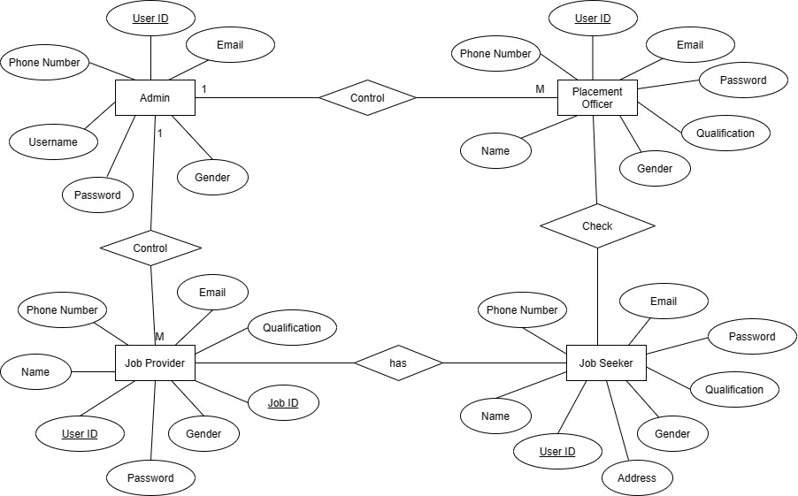

**Tools Used:**

To develop this project, we have used the following tools:

• Draw.io

• Sublime Text

**System Images against the Specification:**

**Admin:**



**Job Provider:**

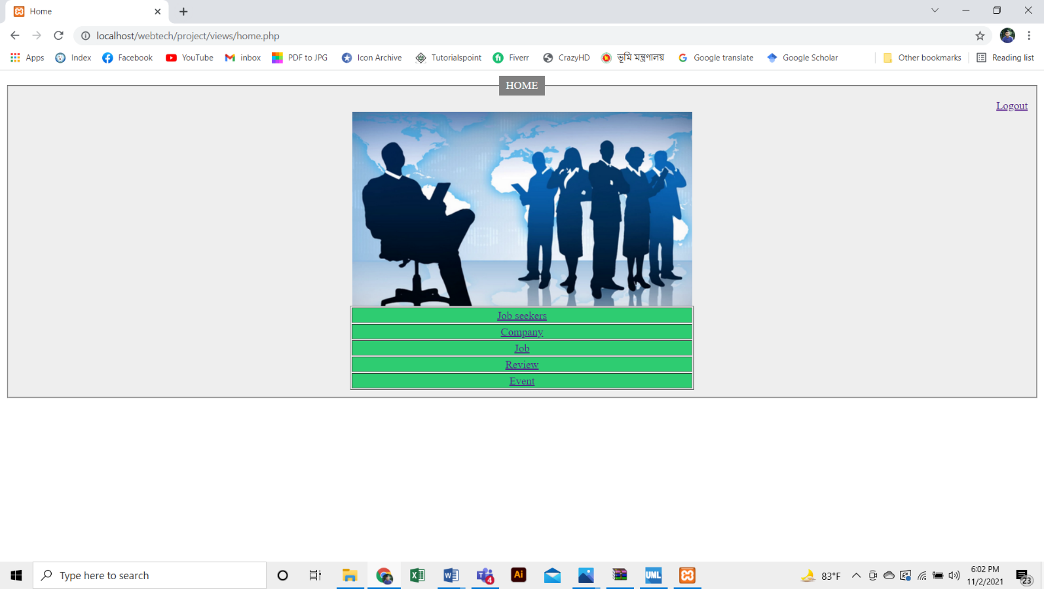

**Job Seekers:**

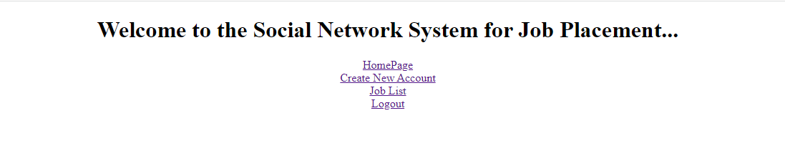

**Impact of this Project:**

A country has many sectors which hold economy of the whole nation and job sector is one of them. From this website all members can communicate with each other. They will get a good collaboration. This website can reduce unemployment form our country. Our project is fully acceptable with the modern Society and environment because job seekers are getting more features and full security system in their account and easily can view many job opportunities which are suggest for them.

**Limitations and Possible Future Improvements:**

* We need to do our network strong so that we can keep the information of all the companies of our country. Any type of job seeker can find their favorite.
* If an employee who was job seeker in this social media leaves a job, then another job seeker can get the job.
* In this project there is no sms system. We try to develop a sms system. We think that it is helpful for job seekers and company. We also try to link up this project with social media like Facebook, twitter.

*[Note: Make sure that your report is maximum 10 pages (including cover page). Print (Colored) the report and submit it with spiral bind.]*

|  |  |  |  |  |  |
| --- | --- | --- | --- | --- | --- |
| CO1.1 and CO2.1 Evaluation: Project Report Evaluation | | | | | |
| Project Proposal  (5) | Background  Study  (5) | Requirement Analysis  (5) | Entity  Diagram  (5) | System Images  against the  Specification (5) | Total (25) |
|  |  |  |  |  |  |
|  | | | | | |